|  |  |
| --- | --- |
| **Plate information** | |
|  | |
| **Plate** | 1 |
| **Repeat** | 1 |
| **Barcode** |  |
| **Measured height** | 14.71 |
| **Inside temperature at start** | 22.86 |
| **Inside temperature at end** | 22.86 |
| **Humidity at start** | 56.6 |
| **Humidity at end** | 56.6 |
| **Ambient temperature at start** | 22.47 |
| **Ambient temperature at end** | 22.66 |
| **Group** | 1 |
| **Label** | new alamar blue(1) |
| **ScanX** | 0 |
| **ScanY** | 0 |
| **Measinfo** | De=1st Ex=Top Em=Top Wdw=N/A (14) |
| **Kinetics** | 0 |
| **Measurement date** | 7/13/2023 1:53:26 PM |
|  | |

|  |
| --- |
| **Background information** |
| Legend:  HDR1 - Plate  HDR2 - Label  HDR3 - Result  HDR4 - Signal  HDR5 - Flashes/Time  HDR6 - Meastime  HDR7 - MeasInfo |
| HDR1 HDR2 HDR3 HDR4 HDR5 HDR6 HDR7  1 new alamar blue 0 1463 1 00:00:00.000 De=1st Ex=Top Em=Top Wdw=N/A (14) |
|  |

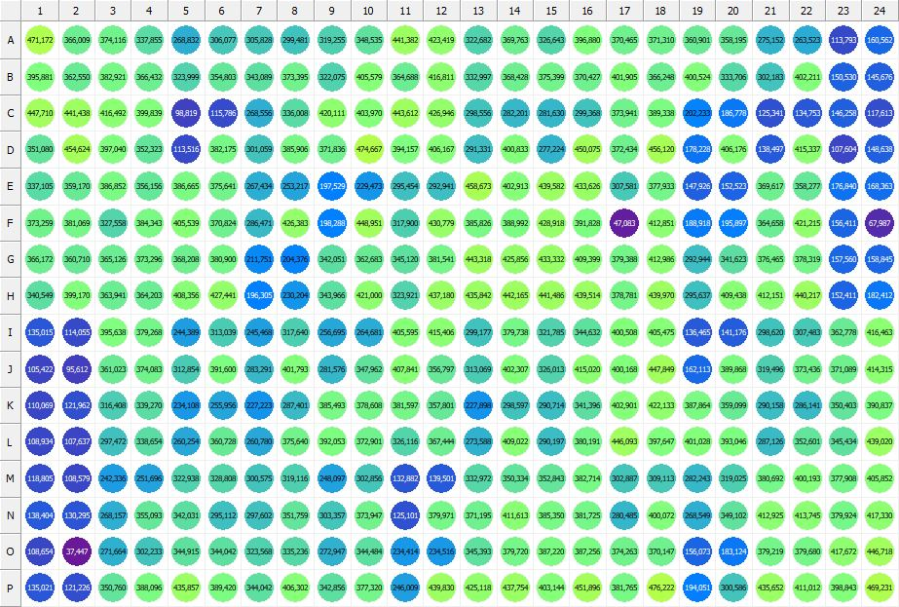

|  |
| --- |
| **Results for new alamar blue(1) - channel 1 (RFU)** |

|  |  |  |  |  |  |  |  |  |  |  |  |  |  |  |  |  |  |  |  |  |  |  |  |  |
| --- | --- | --- | --- | --- | --- | --- | --- | --- | --- | --- | --- | --- | --- | --- | --- | --- | --- | --- | --- | --- | --- | --- | --- | --- |
|  | 01 | 02 | 03 | 04 | 05 | 06 | 07 | 08 | 09 | 10 | 11 | 12 | 13 | 14 | 15 | 16 | 17 | 18 | 19 | 20 | 21 | 22 | 23 | 24 |
| A | 471172 | 366009 | 374116 | 337855 | 268832 | 306077 | 305828 | 299481 | 319255 | 348535 | 441382 | 423419 | 322682 | 369763 | 326643 | 396880 | 370465 | 371310 | 360901 | 358195 | 275152 | 263523 | 113793 | 160562 |
| B | 395881 | 362550 | 382921 | 366432 | 323999 | 354803 | 343089 | 373395 | 322075 | 405579 | 364688 | 416811 | 332997 | 368428 | 375399 | 370427 | 401905 | 366248 | 400524 | 333706 | 302183 | 402211 | 150530 | 145676 |
| C | 447710 | 441438 | 416492 | 399839 | 98819 | 115786 | 268556 | 336008 | 420111 | 403970 | 443612 | 426946 | 298556 | 282201 | 281630 | 299368 | 373941 | 389338 | 202233 | 186778 | 125341 | 134753 | 146258 | 117613 |
| D | 351080 | 454624 | 397040 | 352323 | 113516 | 382175 | 301059 | 385906 | 371836 | 474667 | 394157 | 406167 | 291331 | 400833 | 277224 | 450075 | 372434 | 456120 | 178228 | 406176 | 138497 | 415337 | 107604 | 148638 |
| E | 337105 | 359170 | 386852 | 356156 | 386665 | 375641 | 267434 | 253217 | 197529 | 229473 | 295454 | 292941 | 458673 | 402913 | 439582 | 433626 | 307581 | 377933 | 147926 | 152523 | 369617 | 358277 | 176840 | 168363 |
| F | 373259 | 381069 | 327558 | 384343 | 405539 | 370824 | 286471 | 426383 | 198288 | 448951 | 317900 | 430779 | 385826 | 388992 | 428918 | 391828 | 47083 | 412851 | 188918 | 195897 | 364658 | 421215 | 156411 | 67987 |
| G | 366172 | 360710 | 365126 | 373296 | 368208 | 380900 | 211751 | 204376 | 342051 | 362683 | 345120 | 381541 | 443318 | 425856 | 433332 | 409399 | 379388 | 412986 | 292944 | 341623 | 376465 | 378319 | 157560 | 158845 |
| H | 340549 | 399170 | 363941 | 364203 | 408356 | 427441 | 196305 | 230204 | 343966 | 421000 | 323921 | 437180 | 435842 | 442165 | 441486 | 439514 | 378781 | 439970 | 295637 | 409438 | 412151 | 440217 | 152411 | 182412 |
| I | 135015 | 114055 | 395638 | 379268 | 244389 | 313039 | 245468 | 317640 | 256695 | 264681 | 405595 | 415406 | 299177 | 379738 | 321785 | 344632 | 400508 | 405475 | 136465 | 141176 | 298620 | 307483 | 362778 | 416463 |
| J | 105422 | 95612 | 361023 | 374083 | 312854 | 391600 | 283291 | 401793 | 281576 | 347962 | 407841 | 356797 | 313069 | 402307 | 326013 | 415020 | 400168 | 447849 | 162113 | 389868 | 319496 | 373436 | 371089 | 414315 |
| K | 110069 | 121962 | 316408 | 339270 | 234108 | 255956 | 227223 | 287401 | 385493 | 378608 | 381597 | 357801 | 227898 | 298597 | 290714 | 341396 | 402901 | 422133 | 387864 | 359099 | 290158 | 286141 | 350403 | 390837 |
| L | 108934 | 107637 | 297472 | 338654 | 260254 | 360728 | 260780 | 375640 | 392053 | 372901 | 326116 | 367444 | 273588 | 409022 | 290197 | 380191 | 446093 | 397647 | 401028 | 393046 | 287126 | 352601 | 345434 | 439020 |
| M | 118805 | 108579 | 242336 | 251696 | 322938 | 328808 | 300575 | 319116 | 248097 | 302856 | 132882 | 139501 | 332972 | 350334 | 352843 | 382714 | 302887 | 309113 | 282243 | 319025 | 380692 | 400193 | 377908 | 405852 |
| N | 138404 | 130295 | 268157 | 355093 | 342031 | 295112 | 297602 | 351759 | 303357 | 373947 | 125101 | 379971 | 371195 | 411613 | 385350 | 381725 | 280485 | 400072 | 268549 | 349102 | 412925 | 413745 | 379924 | 417330 |
| O | 108654 | 37447 | 271664 | 302233 | 344915 | 344042 | 323568 | 335236 | 272947 | 344484 | 234414 | 234516 | 345393 | 379720 | 387220 | 387256 | 374263 | 370147 | 156073 | 183124 | 379219 | 379680 | 417672 | 446718 |
| P | 135021 | 121226 | 350760 | 388096 | 435857 | 389420 | 344042 | 406302 | 342856 | 377320 | 246009 | 439830 | 425118 | 437754 | 403144 | 451896 | 381765 | 476222 | 194051 | 300586 | 435652 | 411012 | 398843 | 469231 |

|  |  |
| --- | --- |
| **Plate information** | |
|  | |
| **Plate** | 2 |
| **Repeat** | 1 |
| **Barcode** |  |
| **Measured height** | 14.66 |
| **Inside temperature at start** | 22.86 |
| **Inside temperature at end** | 22.86 |
| **Humidity at start** | 55.9 |
| **Humidity at end** | 56.3 |
| **Ambient temperature at start** | 22.95 |
| **Ambient temperature at end** | 22.76 |
| **Group** | 1 |
| **Label** | new alamar blue(1) |
| **ScanX** | 0 |
| **ScanY** | 0 |
| **Measinfo** | De=1st Ex=Top Em=Top Wdw=N/A (14) |
| **Kinetics** | 0 |
| **Measurement date** | 7/13/2023 1:54:29 PM |
|  | |

|  |
| --- |
| **Background information** |
| Legend:  HDR1 - Plate  HDR2 - Label  HDR3 - Result  HDR4 - Signal  HDR5 - Flashes/Time  HDR6 - Meastime  HDR7 - MeasInfo |
| HDR1 HDR2 HDR3 HDR4 HDR5 HDR6 HDR7  2 new alamar blue 0 1539 1 00:00:00.000 De=1st Ex=Top Em=Top Wdw=N/A (14) |
|  |

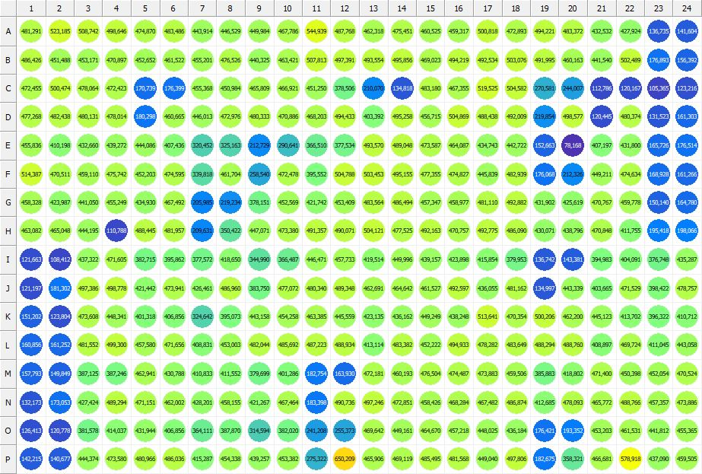

|  |
| --- |
| **Results for new alamar blue(1) - channel 1 (RFU)** |

|  |  |  |  |  |  |  |  |  |  |  |  |  |  |  |  |  |  |  |  |  |  |  |  |  |
| --- | --- | --- | --- | --- | --- | --- | --- | --- | --- | --- | --- | --- | --- | --- | --- | --- | --- | --- | --- | --- | --- | --- | --- | --- |
|  | 01 | 02 | 03 | 04 | 05 | 06 | 07 | 08 | 09 | 10 | 11 | 12 | 13 | 14 | 15 | 16 | 17 | 18 | 19 | 20 | 21 | 22 | 23 | 24 |
| A | 481291 | 523185 | 508742 | 498646 | 474870 | 483486 | 443914 | 446529 | 449984 | 467786 | 544939 | 487768 | 462318 | 475451 | 460525 | 459317 | 500818 | 472893 | 494221 | 483372 | 432532 | 427924 | 136735 | 141604 |
| B | 486426 | 451488 | 453171 | 470897 | 452652 | 461522 | 455201 | 476526 | 440325 | 463421 | 507813 | 497391 | 493554 | 495856 | 469023 | 494219 | 492534 | 503076 | 491995 | 460163 | 441540 | 502489 | 176893 | 156392 |
| C | 472455 | 500474 | 478064 | 472423 | 170739 | 176399 | 455368 | 450984 | 465809 | 466921 | 451250 | 378506 | 210070 | 134818 | 483180 | 467355 | 519525 | 504582 | 270581 | 244007 | 112786 | 120167 | 105365 | 123216 |
| D | 477268 | 482438 | 480131 | 478014 | 180298 | 460665 | 446013 | 472976 | 480333 | 470886 | 468203 | 494433 | 403392 | 495258 | 456715 | 504869 | 488438 | 492009 | 219854 | 498577 | 120445 | 480374 | 131523 | 161303 |
| E | 455836 | 410198 | 432660 | 439272 | 444086 | 407436 | 320452 | 325163 | 212729 | 290641 | 366510 | 377534 | 493570 | 489048 | 473587 | 464087 | 434743 | 442722 | 152663 | 78168 | 407197 | 431800 | 165726 | 176514 |
| F | 514387 | 470511 | 459110 | 475742 | 452203 | 474595 | 339818 | 461704 | 258540 | 472478 | 395552 | 504788 | 503453 | 495155 | 477355 | 474827 | 445839 | 482939 | 176068 | 212326 | 449211 | 474634 | 168928 | 161266 |
| G | 458328 | 423987 | 441050 | 455249 | 434930 | 467492 | 205985 | 219234 | 378151 | 452569 | 421742 | 453409 | 483564 | 486494 | 457347 | 458977 | 481110 | 492882 | 431902 | 425619 | 470767 | 459778 | 150140 | 164780 |
| H | 463082 | 465048 | 444195 | 110788 | 488445 | 481957 | 209631 | 350422 | 447071 | 473380 | 491357 | 490071 | 504121 | 477525 | 492163 | 470757 | 492775 | 486090 | 430071 | 438796 | 470848 | 411755 | 195418 | 198066 |
| I | 121663 | 108412 | 437322 | 471605 | 382715 | 395862 | 377572 | 418650 | 344990 | 366487 | 446471 | 457733 | 419514 | 449996 | 439157 | 423898 | 415854 | 379953 | 136742 | 143381 | 394983 | 404091 | 376748 | 435287 |
| J | 121197 | 181302 | 497386 | 498778 | 421442 | 473941 | 426461 | 486960 | 383750 | 477072 | 480340 | 489348 | 462691 | 464642 | 461527 | 492597 | 436055 | 481162 | 134997 | 443339 | 403665 | 471529 | 398422 | 478757 |
| K | 151202 | 123804 | 473608 | 448341 | 401318 | 406856 | 324642 | 395073 | 443158 | 454258 | 463385 | 445559 | 423135 | 436162 | 449249 | 438248 | 513641 | 470354 | 500206 | 462200 | 445123 | 413702 | 396322 | 410712 |
| L | 160856 | 161252 | 481552 | 499300 | 457580 | 471656 | 408831 | 453003 | 482044 | 485692 | 487223 | 488934 | 413114 | 483382 | 452222 | 494933 | 478282 | 483649 | 488294 | 488760 | 408897 | 469724 | 411045 | 443058 |
| M | 157793 | 149849 | 387125 | 387246 | 462941 | 430788 | 410833 | 411552 | 379699 | 401286 | 182754 | 163930 | 472181 | 460193 | 476504 | 474487 | 473883 | 459506 | 385883 | 418802 | 471400 | 450398 | 452054 | 470524 |
| N | 132173 | 173053 | 427424 | 489294 | 471151 | 462002 | 428201 | 458155 | 421267 | 467464 | 183398 | 490736 | 497246 | 472851 | 458426 | 468284 | 467482 | 486874 | 412685 | 478093 | 465772 | 488766 | 457357 | 473886 |
| O | 126413 | 120778 | 381578 | 414037 | 431944 | 406856 | 364111 | 387870 | 314594 | 382020 | 241208 | 255373 | 469642 | 449161 | 464670 | 457218 | 448025 | 436184 | 176421 | 193352 | 453203 | 461531 | 441812 | 455365 |
| P | 142215 | 140677 | 444374 | 473580 | 480966 | 486036 | 415287 | 454338 | 439257 | 453382 | 275322 | 650209 | 465906 | 469119 | 485495 | 481568 | 449040 | 497806 | 182675 | 358321 | 466681 | 578918 | 437090 | 459505 |

|  |  |
| --- | --- |
| **Plate information** | |
|  | |
| **Plate** | 3 |
| **Repeat** | 1 |
| **Barcode** |  |
| **Measured height** | 14.66 |
| **Inside temperature at start** | 22.86 |
| **Inside temperature at end** | 22.96 |
| **Humidity at start** | 56.2 |
| **Humidity at end** | 56.6 |
| **Ambient temperature at start** | 22.57 |
| **Ambient temperature at end** | 22.57 |
| **Group** | 1 |
| **Label** | new alamar blue(1) |
| **ScanX** | 0 |
| **ScanY** | 0 |
| **Measinfo** | De=1st Ex=Top Em=Top Wdw=N/A (14) |
| **Kinetics** | 0 |
| **Measurement date** | 7/13/2023 1:55:40 PM |
|  | |

|  |
| --- |
| **Background information** |
| Legend:  HDR1 - Plate  HDR2 - Label  HDR3 - Result  HDR4 - Signal  HDR5 - Flashes/Time  HDR6 - Meastime  HDR7 - MeasInfo |
| HDR1 HDR2 HDR3 HDR4 HDR5 HDR6 HDR7  3 new alamar blue 0 1537 1 00:00:00.000 De=1st Ex=Top Em=Top Wdw=N/A (14) |
|  |

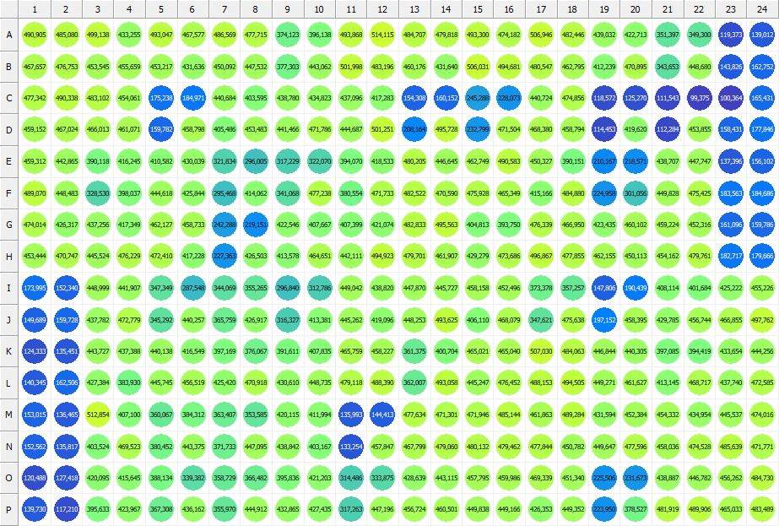

|  |
| --- |
| **Results for new alamar blue(1) - channel 1 (RFU)** |

|  |  |  |  |  |  |  |  |  |  |  |  |  |  |  |  |  |  |  |  |  |  |  |  |  |
| --- | --- | --- | --- | --- | --- | --- | --- | --- | --- | --- | --- | --- | --- | --- | --- | --- | --- | --- | --- | --- | --- | --- | --- | --- |
|  | 01 | 02 | 03 | 04 | 05 | 06 | 07 | 08 | 09 | 10 | 11 | 12 | 13 | 14 | 15 | 16 | 17 | 18 | 19 | 20 | 21 | 22 | 23 | 24 |
| A | 490905 | 485080 | 499138 | 433255 | 493047 | 467577 | 486569 | 477715 | 374123 | 396138 | 493868 | 514115 | 484707 | 479818 | 493300 | 474182 | 506946 | 482446 | 439032 | 422713 | 351397 | 349300 | 119373 | 139012 |
| B | 467657 | 476753 | 453545 | 455659 | 453217 | 431636 | 450092 | 447532 | 377303 | 443062 | 501998 | 483196 | 460176 | 431640 | 506031 | 494681 | 480547 | 462795 | 412239 | 470895 | 343653 | 448680 | 143826 | 162752 |
| C | 477342 | 490338 | 483102 | 454061 | 175238 | 184971 | 440684 | 403595 | 438780 | 434823 | 437096 | 417283 | 154308 | 160152 | 245288 | 228073 | 440724 | 474856 | 118572 | 125270 | 111543 | 99375 | 100364 | 165431 |
| D | 459152 | 467024 | 466013 | 461071 | 159782 | 458798 | 405486 | 453483 | 441466 | 471786 | 444687 | 501251 | 208164 | 495728 | 232799 | 471504 | 468380 | 458794 | 114453 | 419620 | 112284 | 453855 | 158431 | 177846 |
| E | 459312 | 442865 | 390118 | 416245 | 410582 | 430039 | 321834 | 296005 | 317229 | 322070 | 394070 | 418533 | 480205 | 446645 | 462749 | 490583 | 450327 | 390151 | 210167 | 218571 | 438707 | 447747 | 137396 | 156102 |
| F | 489070 | 448483 | 328530 | 398037 | 444618 | 425844 | 295468 | 414062 | 341068 | 477238 | 380554 | 471733 | 482522 | 470590 | 475928 | 465349 | 415166 | 484880 | 224958 | 301056 | 449828 | 475425 | 183563 | 184686 |
| G | 474014 | 426317 | 437256 | 417349 | 462127 | 458733 | 242288 | 219151 | 422546 | 407667 | 407399 | 421074 | 482833 | 495563 | 404813 | 393750 | 476339 | 466950 | 423435 | 460102 | 459224 | 452316 | 161096 | 159786 |
| H | 453444 | 470747 | 445524 | 476229 | 472410 | 417228 | 227363 | 426503 | 413578 | 464651 | 442111 | 494923 | 479701 | 461907 | 429279 | 473686 | 496867 | 477855 | 462155 | 450113 | 454162 | 479761 | 182717 | 179666 |
| I | 173995 | 152340 | 448999 | 441907 | 347349 | 287548 | 344069 | 355265 | 296840 | 312786 | 449042 | 438820 | 447870 | 445727 | 458158 | 452496 | 373378 | 357257 | 147806 | 190439 | 408114 | 401684 | 425222 | 455226 |
| J | 149689 | 159728 | 437782 | 472779 | 345292 | 440257 | 365759 | 426917 | 316327 | 413381 | 445262 | 419096 | 448253 | 493625 | 406110 | 468079 | 347621 | 475638 | 197152 | 458395 | 429785 | 456744 | 466855 | 497762 |
| K | 124333 | 135451 | 443727 | 437388 | 440138 | 416549 | 397169 | 376067 | 391611 | 407835 | 465759 | 458227 | 361375 | 400704 | 465021 | 465040 | 507030 | 484063 | 446844 | 440305 | 397085 | 394419 | 433654 | 444256 |
| L | 140345 | 162506 | 427384 | 383930 | 445745 | 456519 | 425420 | 470918 | 430610 | 448735 | 479118 | 488390 | 362007 | 493058 | 445247 | 476452 | 488153 | 494505 | 449271 | 461627 | 413145 | 468717 | 437740 | 472585 |
| M | 153015 | 136465 | 512854 | 407100 | 360067 | 384312 | 363407 | 353585 | 420115 | 411994 | 135993 | 144413 | 477634 | 471301 | 471946 | 485144 | 461863 | 489284 | 431594 | 452384 | 454332 | 434954 | 445537 | 474016 |
| N | 152562 | 135817 | 403524 | 469523 | 380452 | 443375 | 371733 | 447095 | 438842 | 403167 | 133254 | 457847 | 467799 | 479060 | 480132 | 479462 | 477844 | 450782 | 449647 | 477596 | 458036 | 474528 | 485639 | 471771 |
| O | 120488 | 127418 | 420095 | 415645 | 388134 | 339382 | 358729 | 366482 | 395836 | 421203 | 314486 | 333875 | 428639 | 443115 | 457795 | 459986 | 469339 | 451340 | 225506 | 231673 | 438887 | 446782 | 456262 | 484730 |
| P | 139730 | 117210 | 395633 | 423967 | 367308 | 436162 | 355970 | 444912 | 432865 | 427435 | 317263 | 447196 | 456724 | 460501 | 449838 | 449166 | 426353 | 449352 | 223950 | 378527 | 481919 | 489906 | 465033 | 483489 |

|  |  |
| --- | --- |
| **Plate information** | |
|  | |
| **Plate** | 4 |
| **Repeat** | 1 |
| **Barcode** |  |
| **Measured height** | 14.66 |
| **Inside temperature at start** | 22.96 |
| **Inside temperature at end** | 22.96 |
| **Humidity at start** | 56.5 |
| **Humidity at end** | 57 |
| **Ambient temperature at start** | 22.47 |
| **Ambient temperature at end** | 22.18 |
| **Group** | 1 |
| **Label** | new alamar blue(1) |
| **ScanX** | 0 |
| **ScanY** | 0 |
| **Measinfo** | De=1st Ex=Top Em=Top Wdw=N/A (14) |
| **Kinetics** | 0 |
| **Measurement date** | 7/13/2023 1:56:48 PM |
|  | |

|  |
| --- |
| **Background information** |
| Legend:  HDR1 - Plate  HDR2 - Label  HDR3 - Result  HDR4 - Signal  HDR5 - Flashes/Time  HDR6 - Meastime  HDR7 - MeasInfo |
| HDR1 HDR2 HDR3 HDR4 HDR5 HDR6 HDR7  4 new alamar blue 0 1341 1 00:00:00.000 De=1st Ex=Top Em=Top Wdw=N/A (14) |
|  |

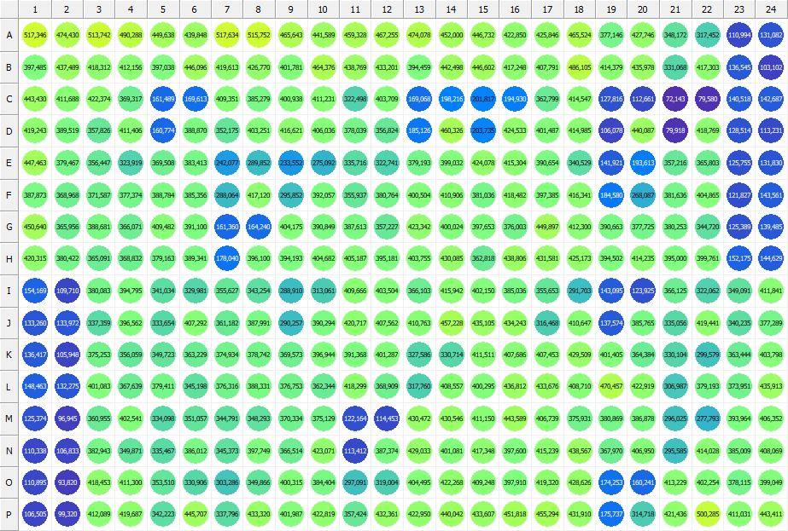

|  |
| --- |
| **Results for new alamar blue(1) - channel 1 (RFU)** |

|  |  |  |  |  |  |  |  |  |  |  |  |  |  |  |  |  |  |  |  |  |  |  |  |  |
| --- | --- | --- | --- | --- | --- | --- | --- | --- | --- | --- | --- | --- | --- | --- | --- | --- | --- | --- | --- | --- | --- | --- | --- | --- |
|  | 01 | 02 | 03 | 04 | 05 | 06 | 07 | 08 | 09 | 10 | 11 | 12 | 13 | 14 | 15 | 16 | 17 | 18 | 19 | 20 | 21 | 22 | 23 | 24 |
| A | 517346 | 474430 | 513742 | 490288 | 449638 | 439848 | 517634 | 515752 | 465643 | 441589 | 459328 | 467255 | 474078 | 452000 | 446732 | 422850 | 425846 | 465524 | 377146 | 427746 | 348172 | 317452 | 110994 | 131082 |
| B | 397485 | 437489 | 418312 | 412156 | 397038 | 446096 | 419613 | 426770 | 401781 | 464376 | 438769 | 433201 | 394459 | 442498 | 446602 | 417248 | 407791 | 486105 | 414379 | 435978 | 331068 | 417303 | 136545 | 103102 |
| C | 443430 | 411688 | 422374 | 369317 | 161489 | 169613 | 409351 | 385279 | 400938 | 411231 | 322498 | 403709 | 169068 | 198216 | 201817 | 194930 | 362799 | 414547 | 127816 | 112661 | 72143 | 79580 | 140518 | 142687 |
| D | 419243 | 389519 | 357826 | 411406 | 160774 | 388870 | 352175 | 403251 | 416621 | 406036 | 378039 | 356824 | 185126 | 460326 | 203735 | 424533 | 401487 | 414985 | 106078 | 440087 | 79918 | 418769 | 128514 | 113231 |
| E | 447463 | 379467 | 356447 | 323919 | 369508 | 383413 | 242077 | 289852 | 233552 | 275092 | 335716 | 322741 | 379193 | 399032 | 424078 | 415304 | 390654 | 340529 | 141921 | 193613 | 357216 | 365803 | 125755 | 131830 |
| F | 387873 | 368968 | 371587 | 377374 | 388784 | 385356 | 288064 | 417120 | 295852 | 392057 | 355937 | 380764 | 400504 | 410906 | 381036 | 418482 | 397385 | 416341 | 184580 | 268087 | 381636 | 404865 | 121827 | 143561 |
| G | 450640 | 365956 | 388681 | 366071 | 409482 | 391100 | 161360 | 164240 | 404175 | 390849 | 387613 | 357227 | 423342 | 400024 | 397653 | 376003 | 449897 | 412300 | 390663 | 377725 | 380253 | 344720 | 125389 | 139485 |
| H | 420315 | 380422 | 365091 | 368832 | 379163 | 389341 | 178040 | 396100 | 394193 | 404682 | 405187 | 395181 | 403755 | 430085 | 362818 | 438806 | 431581 | 425173 | 394502 | 414235 | 395000 | 399761 | 152175 | 144629 |
| I | 154169 | 109710 | 380083 | 394795 | 341034 | 329981 | 355627 | 343254 | 288910 | 313061 | 409666 | 403504 | 366103 | 415942 | 402150 | 385036 | 355653 | 291703 | 143095 | 123925 | 366125 | 322062 | 349091 | 411841 |
| J | 133260 | 133972 | 337359 | 396562 | 333654 | 407292 | 361182 | 387991 | 290257 | 390294 | 420717 | 407562 | 410763 | 457228 | 435105 | 434243 | 316468 | 410647 | 137574 | 385765 | 335056 | 419441 | 340235 | 377289 |
| K | 136417 | 105948 | 375253 | 356059 | 349723 | 363229 | 374934 | 378742 | 369573 | 396944 | 391368 | 401287 | 327586 | 330714 | 411511 | 407686 | 407453 | 429509 | 401405 | 364384 | 330104 | 299579 | 363444 | 403798 |
| L | 148463 | 132275 | 401083 | 367639 | 379411 | 345198 | 376316 | 388331 | 376753 | 362344 | 418299 | 368909 | 317760 | 408557 | 400295 | 436812 | 433676 | 408710 | 470457 | 422919 | 306987 | 379193 | 373951 | 435913 |
| M | 125374 | 96945 | 360955 | 402541 | 334098 | 351057 | 344791 | 348293 | 370334 | 375129 | 122164 | 114453 | 430472 | 430546 | 411150 | 443589 | 406739 | 375931 | 380869 | 386878 | 296025 | 277793 | 393964 | 406352 |
| N | 110338 | 106833 | 382943 | 349871 | 335467 | 386012 | 345373 | 397749 | 366514 | 423071 | 113412 | 387374 | 429033 | 401081 | 417348 | 397600 | 415239 | 438567 | 367970 | 406950 | 295585 | 414028 | 385009 | 408069 |
| O | 110895 | 93820 | 418453 | 411300 | 353510 | 330906 | 303286 | 349866 | 400315 | 384404 | 297091 | 319004 | 404495 | 422268 | 409248 | 397910 | 419320 | 428626 | 174253 | 160241 | 413229 | 402254 | 378115 | 399049 |
| P | 106505 | 99320 | 412089 | 419687 | 342223 | 445707 | 337796 | 433320 | 401987 | 422819 | 357424 | 432361 | 422950 | 440042 | 433607 | 451818 | 455294 | 431910 | 175737 | 314718 | 421436 | 500285 | 411031 | 443411 |

|  |  |
| --- | --- |
| **Plate information** | |
|  | |
| **Plate** | 5 |
| **Repeat** | 1 |
| **Barcode** |  |
| **Measured height** | 14.66 |
| **Inside temperature at start** | 22.96 |
| **Inside temperature at end** | 22.96 |
| **Humidity at start** | 57.1 |
| **Humidity at end** | 56.3 |
| **Ambient temperature at start** | 22.18 |
| **Ambient temperature at end** | 22.57 |
| **Group** | 1 |
| **Label** | new alamar blue(1) |
| **ScanX** | 0 |
| **ScanY** | 0 |
| **Measinfo** | De=1st Ex=Top Em=Top Wdw=N/A (14) |
| **Kinetics** | 0 |
| **Measurement date** | 7/13/2023 1:58:06 PM |
|  | |

|  |
| --- |
| **Background information** |
| Legend:  HDR1 - Plate  HDR2 - Label  HDR3 - Result  HDR4 - Signal  HDR5 - Flashes/Time  HDR6 - Meastime  HDR7 - MeasInfo |
| HDR1 HDR2 HDR3 HDR4 HDR5 HDR6 HDR7  5 new alamar blue 0 1534 1 00:00:00.000 De=1st Ex=Top Em=Top Wdw=N/A (14) |
|  |

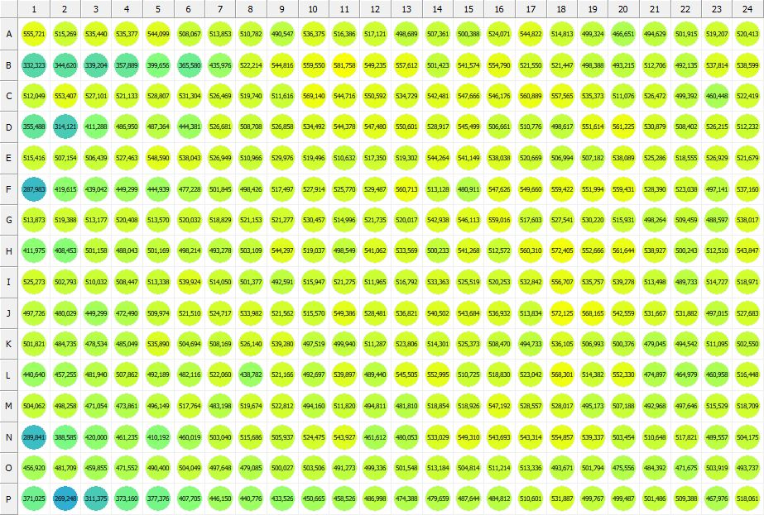

|  |
| --- |
| **Results for new alamar blue(1) - channel 1 (RFU)** |

|  |  |  |  |  |  |  |  |  |  |  |  |  |  |  |  |  |  |  |  |  |  |  |  |  |
| --- | --- | --- | --- | --- | --- | --- | --- | --- | --- | --- | --- | --- | --- | --- | --- | --- | --- | --- | --- | --- | --- | --- | --- | --- |
|  | 01 | 02 | 03 | 04 | 05 | 06 | 07 | 08 | 09 | 10 | 11 | 12 | 13 | 14 | 15 | 16 | 17 | 18 | 19 | 20 | 21 | 22 | 23 | 24 |
| A | 555721 | 515269 | 535440 | 535377 | 544099 | 508067 | 513853 | 510782 | 490547 | 536375 | 516386 | 517121 | 498689 | 507361 | 500388 | 524071 | 544822 | 514813 | 499324 | 466651 | 494629 | 501915 | 519207 | 520413 |
| B | 332323 | 344620 | 339204 | 357889 | 399656 | 365580 | 435976 | 522214 | 544816 | 559550 | 581758 | 549235 | 557612 | 501423 | 541574 | 554790 | 521550 | 521447 | 498388 | 493215 | 512706 | 492135 | 537814 | 538599 |
| C | 512049 | 553407 | 527101 | 521133 | 528807 | 531304 | 526469 | 519740 | 511616 | 569140 | 544716 | 550592 | 534729 | 542481 | 547666 | 546176 | 560889 | 557565 | 535373 | 511076 | 526472 | 499392 | 460448 | 522419 |
| D | 355488 | 314121 | 411288 | 486950 | 487364 | 444381 | 526681 | 508708 | 526858 | 534492 | 544378 | 547480 | 550601 | 528917 | 545499 | 506661 | 510776 | 498617 | 551614 | 561225 | 530879 | 508402 | 526215 | 512232 |
| E | 515416 | 507154 | 506439 | 527463 | 548590 | 538043 | 526949 | 510966 | 529976 | 519496 | 510632 | 517350 | 519302 | 544264 | 541149 | 538038 | 520669 | 506994 | 507182 | 538089 | 525286 | 518555 | 526929 | 521679 |
| F | 287983 | 419615 | 439042 | 449299 | 444939 | 477228 | 501845 | 498426 | 517497 | 527914 | 525770 | 529487 | 560713 | 513128 | 480911 | 547626 | 549660 | 559422 | 551994 | 559431 | 528390 | 523038 | 497141 | 537160 |
| G | 513873 | 519388 | 513177 | 520408 | 513570 | 520032 | 518829 | 521153 | 521277 | 530457 | 514996 | 521735 | 520017 | 542938 | 546113 | 559016 | 517603 | 527541 | 530220 | 515931 | 498264 | 509459 | 488597 | 538017 |
| H | 411975 | 408453 | 501158 | 488043 | 501169 | 498214 | 493278 | 503109 | 544297 | 519037 | 498549 | 541062 | 533569 | 500233 | 541268 | 512572 | 560310 | 572405 | 552666 | 561644 | 538927 | 500243 | 512510 | 543847 |
| I | 525273 | 502793 | 510032 | 508447 | 513338 | 539924 | 514050 | 501377 | 492591 | 515947 | 521275 | 511965 | 516792 | 533363 | 525519 | 520253 | 532842 | 556707 | 535757 | 539278 | 513498 | 489733 | 514727 | 518971 |
| J | 497726 | 480029 | 449299 | 472490 | 509974 | 521510 | 524717 | 533982 | 521562 | 515570 | 549386 | 528481 | 536821 | 540502 | 543684 | 536932 | 513834 | 572125 | 568165 | 542559 | 531667 | 531882 | 497015 | 527683 |
| K | 501821 | 484735 | 478534 | 485049 | 535890 | 504694 | 508169 | 526140 | 539280 | 497519 | 499940 | 511287 | 523806 | 514301 | 525373 | 508470 | 494733 | 536105 | 506993 | 500376 | 479045 | 494542 | 511095 | 502550 |
| L | 440640 | 457255 | 481940 | 507862 | 492189 | 482116 | 522060 | 438782 | 521166 | 492697 | 539897 | 489440 | 545505 | 552995 | 510725 | 518830 | 523042 | 568301 | 514382 | 552330 | 474897 | 464979 | 460958 | 516448 |
| M | 504062 | 498258 | 471054 | 473861 | 496149 | 517764 | 483198 | 519674 | 522812 | 494160 | 511820 | 494811 | 481810 | 518854 | 518926 | 547192 | 528557 | 528017 | 495173 | 507188 | 492968 | 497646 | 515529 | 518709 |
| N | 289841 | 388585 | 420000 | 461235 | 410192 | 460019 | 503040 | 515686 | 505937 | 524475 | 543927 | 461612 | 480053 | 533029 | 549310 | 543693 | 543314 | 554857 | 539337 | 503454 | 510648 | 517821 | 489557 | 504175 |
| O | 456920 | 481709 | 459855 | 471552 | 490400 | 504049 | 497648 | 479085 | 500027 | 503506 | 491273 | 499336 | 501548 | 513184 | 504814 | 511214 | 513336 | 493671 | 501794 | 475556 | 484392 | 471675 | 503919 | 493737 |
| P | 371025 | 269248 | 311375 | 373160 | 377376 | 407705 | 446150 | 440776 | 433526 | 450665 | 458526 | 486998 | 474388 | 479659 | 487644 | 484812 | 510601 | 531887 | 499767 | 499487 | 501486 | 509388 | 467976 | 518061 |

|  |  |
| --- | --- |
|  | |
| **Basic assay information** | |
| **Assay ID** | 25614 |
| **Assay Started** | 7/13/2023 1:52:43 PM |
| **Assay Finished** | 7/13/2023 1:58:25 PM |
| **Assay Exported** | 7/24/2023 11:06:39 AM |
| **Protocol ID** | 100177 |
| **Protocol Name** | TRF-384 Alamar blue+BS+nbw |
| **Serial#** | 1020141 |
|  | |
|  | |
|  | |
| **Protocol information** | |
| **Protocol:** | |
| **Protocol name** | TRF-384 Alamar blue+BS+nbw |
| **Number of assay repeats** | 1 |
| **Start assay repeat each** | N/A |
| **Number of plate repeats** | 1 |
| **Start plate repeat each** | N/A |
| **Is label meas. height used** | Yes |
| **Height of measurement** | Defined in label |
| **Is gripper height used** | No |
| **Mode of measurement** | By Rows, bi-directional |
| **Rotated plate** | No |
| **Soft move** | No |
| **Protocol notes** |  |
|  | |
| **Plate type:** | |
| **Name of the plate type** | Jaffe 384 General |
| **Number of rows** | 16 |
| **Number of columns** | 24 |
| **Number of the wells in the plate** | 384 |
| **Height of the plate** | 14.35 mm |
|  | |
| **Coordinates of corners:** | |
| **Jaffe 384 General** | |
| 12.13 mm x------------------------------------------------------ x 115.63 mm  8.99 mm 8.99 mm | |
| 12.13 mm x------------------------------------------------------ x 115.63 mm  76.49 mm 76.49 mm | |
|  | |
|  | |

|  |  |
| --- | --- |
| **Platemap:** | |
| **Plate** | 1 |
| **Group** | 1 |
|  | |

|  |  |  |  |  |  |  |  |  |  |  |  |  |  |  |  |  |  |  |  |  |  |  |  |  |
| --- | --- | --- | --- | --- | --- | --- | --- | --- | --- | --- | --- | --- | --- | --- | --- | --- | --- | --- | --- | --- | --- | --- | --- | --- |
|  | **01** | **02** | **03** | **04** | **05** | **06** | **07** | **08** | **09** | **10** | **11** | **12** | **13** | **14** | **15** | **16** | **17** | **18** | **19** | **20** | **21** | **22** | **23** | **24** |
| **A** | - | - | - | - | - | - | - | - | - | - | - | - | - | - | - | - | - | - | - | - | - | - | - | - |
| **B** | - | - | - | - | - | - | - | - | - | - | - | - | - | - | - | - | - | - | - | - | - | - | - | - |
| **C** | - | - | - | - | - | - | - | - | - | - | - | - | - | - | - | - | - | - | - | - | - | - | - | - |
| **D** | - | - | - | - | - | - | - | - | - | - | - | - | - | - | - | - | - | - | - | - | - | - | - | - |
| **E** | - | - | - | - | - | - | - | - | - | - | - | - | - | - | - | - | - | - | - | - | - | - | - | - |
| **F** | - | - | - | - | - | - | - | - | - | - | - | - | - | - | - | - | - | - | - | - | - | - | - | - |
| **G** | - | - | - | - | - | - | - | - | - | - | - | - | - | - | - | - | - | - | - | - | - | - | - | - |
| **H** | - | - | - | - | - | - | - | - | - | - | - | - | - | - | - | - | - | - | - | - | - | - | - | - |
| **I** | - | - | - | - | - | - | - | - | - | - | - | - | - | - | - | - | - | - | - | - | - | - | - | - |
| **J** | - | - | - | - | - | - | - | - | - | - | - | - | - | - | - | - | - | - | - | - | - | - | - | - |
| **K** | - | - | - | - | - | - | - | - | - | - | - | - | - | - | - | - | - | - | - | - | - | - | - | - |
| **L** | - | - | - | - | - | - | - | - | - | - | - | - | - | - | - | - | - | - | - | - | - | - | - | - |
| **M** | - | - | - | - | - | - | - | - | - | - | - | - | - | - | - | - | - | - | - | - | - | - | - | - |
| **N** | - | - | - | - | - | - | - | - | - | - | - | - | - | - | - | - | - | - | - | - | - | - | - | - |
| **O** | - | - | - | - | - | - | - | - | - | - | - | - | - | - | - | - | - | - | - | - | - | - | - | - |
| **P** | - | - | - | - | - | - | - | - | - | - | - | - | - | - | - | - | - | - | - | - | - | - | - | - |

|  |  |
| --- | --- |
|  | |
| **-** | Undefined |
|  | |
|  | |

|  |  |
| --- | --- |
| **Calculations:** | |
| **No calculations.** | |
|  | |
| **Auto export parameters:** | |
| **Export format** | Plate2 |
| **Include basic assay information** | Yes |
| **Place assay information at** | End of file |
| **Include basic plate information** | Yes |
| **Place plate information at** | End of plate |
| **Include protocol information** | Yes |
| **Protocol info level** | Large |
| **Include error and warning information** | Yes |
| **Include background information** | Yes |
| **Add plate number to the file name** | Yes |
| **Each plate to separate file** | No |
| **Field separator to use** | System |
| **File name format** | <DefaultDataFolder>\<Date>\<ProtocolName>_<AssayID>.csv |
|  | |
| **Operations:** | |
| Plate 1  Group 1  Measurement  Label..................................................... new alamar blue(1) | |
| **Labels:** | |
| **new alamar blue** | 4000013 |
| **Top mirror** | General |
| **Bottom mirror** | N/A |
| **Exc. filter** | Photometric 530 |
| **Using of excitation filter** | Top |
| **2nd exc. filter** | N/A |
| **Using of 2nd excitation filter** | Top |
| **Ems. filter** | Photometric 590 |
| **2nd ems. filter** | N/A |
| **Measurement height** | 6.5 mm |
| **Number of flashes** | 1 |
| **Number of flashes integrated** | 1 |
| **PMT gain** | 1 |
| **Excitation light** | 0% |
| **Reference excitation light** | 100% |
| **Emission light** | 100% |
| **Reference AD gain** | 2 |
| **Reference signal** | 256388 |
| **Last edited** | 10/13/2006 11:04:00 AM |
| **Last edited by** | EnVision |
| **Factory preset** | No |
|  | |
| **Filters:** | |
| **Photometric 530** | 310 |
| **Filter type** | Excitation |
| **Description** | P530 CWL=530nm BW=8nm Tmin=55% |
| **Used with** | Absorbance,DELFIA - Time-resolved Fluorescence,Fluorescence Intensity,Fluorescence Polarization,LANCE - Time-resolved Fluorescence |
| **Last edited** | 5/24/2023 12:39:03 PM |
| **Last edited by** | Installation |
| **Factory preset** | Yes |
|  | |
| **Photometric 590** | 314 |
| **Filter type** | Excitation |
| **Description** | P590 CWL=590nm BW=8nm Tmin=40% |
| **Used with** | Absorbance,DELFIA - Time-resolved Fluorescence,Fluorescence Intensity,Fluorescence Polarization,LANCE - Time-resolved FluorescenceAbsorbance,DELFIA - Time-resolved Fluorescence,Fluorescence Intensity,Fluorescence Polarization,LANCE - Time-resolved Fluorescence |
| **Last edited** | 5/24/2023 12:39:03 PM |
| **Last edited by** | Installation |
| **Factory preset** | Yes |
|  | |
| **Mirror modules:** | |
| **General** | 401 |
| **Used by** | Top |
| **Dual** | No |
| **Bias** | No |
| **Description** | BS50 |
| **Used with** | Luminescence,DELFIA - Time-resolved Fluorescence,Fluorescence Intensity,Fluorescence Polarization,LANCE - Time-resolved Fluorescence |
| **Last edited** | 5/24/2023 12:39:03 PM |
| **Last edited by** | Installation |
| **Factory preset** | Yes |
|  | |
| **Instrument:** | |
| **Serial number** | 1020141 |
| **Nickname** | EnVision |
|  | |
|  | |
|  | |
|  | |
| **Notifications:** | |
| Assay notifications:  INFO: Assay aborted at plate 5 plate repeat 1 and well P01. There may be missing results | |
|  | |
|  | |

|  |
| --- |
|  |
| **Exported with EnVision Workstation version 1.14.3049.1534** |